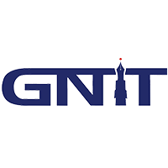 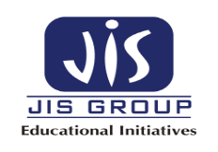

# Lecture-2 Topology and Transmission Modes

# Computer Network Types

A computer network is a group of computers linked to each other that enables the computer to communicate with another computer and share their resources, data, and applications.

A computer network can be categorized by their size. A **computer network** is mainly of **four types**:

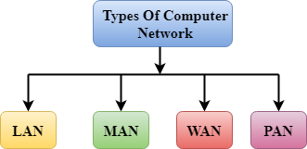

* LAN(Local Area Network)
* PAN(Personal Area Network)
* MAN(Metropolitan Area Network)
* WAN(Wide Area Network)

## LAN(Local Area Network)

* Local Area Network is a group of computers connected to each other in a small area such as building, office.
* LAN is used for connecting two or more personal computers through a communication medium such as twisted pair, coaxial cable, etc.
* It is less costly as it is built with inexpensive hardware such as hubs, network adapters, and ethernet cables.
* The data is transferred at an extremely faster rate in Local Area Network.
* Local Area Network provides higher security.

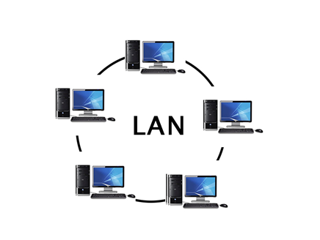

## PAN (Personal Area Network)

* Personal Area Network is a network arranged within an individual person, typically within a range of 10 meters.
* Personal Area Network is used for connecting the computer devices of personal use is known as Personal Area Network.
* **Thomas Zimmerman** was the first research scientist to bring the idea of the Personal Area Network.
* Personal Area Network covers an area of **30 feet**.
* Personal computer devices that are used to develop the personal area network are the laptop, mobile phones, media player and play stations.

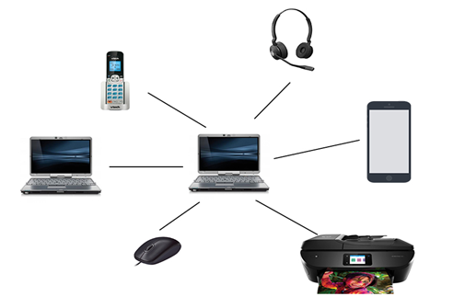

**There are two types of Personal Area Network:**

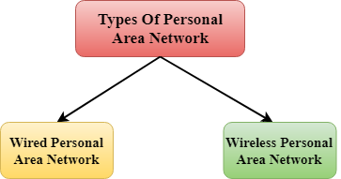

* Wired Personal Area Network
* Wireless Personal Area Network

**Wireless Personal Area Network:** Wireless Personal Area Network is developed by simply using wireless technologies such as WiFi, Bluetooth. It is a low range network.

**Wired Personal Area Network:** Wired Personal Area Network is created by using the USB.

### Examples Of Personal Area Network:

* **Body Area Network:** Body Area Network is a network that moves with a person. **For example**, a mobile network moves with a person. Suppose a person establishes a network connection and then creates a connection with another device to share the information.
* **Offline Network:** An offline network can be created inside the home, so it is also known as a **home network**. A home network is designed to integrate the devices such as printers, computer, television but they are not connected to the internet.
* **Small Home Office:** It is used to connect a variety of devices to the internet and to a corporate network using a VPN

## MAN(Metropolitan Area Network)

* A metropolitan area network is a network that covers a larger geographic area by interconnecting a different LAN to form a larger network.
* Government agencies use MAN to connect to the citizens and private industries.
* In MAN, various LANs are connected to each other through a telephone exchange line.
* It has a higher range than Local Area Network (LAN).

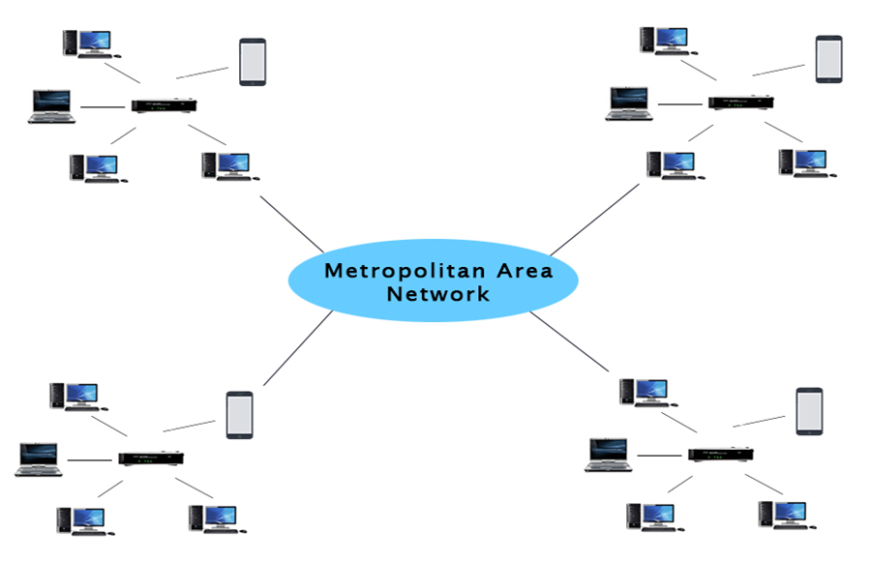

### Uses of Metropolitan Area Network:

* MAN is used in communication between the banks in a city.
* It can be used in an Airline Reservation.
* It can be used in a college within a city.
* It can also be used for communication in the military.

WAN (Wide Area Network)

* A Wide Area Network is a network that extends over a large geographical area such as states or countries.
* A Wide Area Network is quite bigger network than the LAN.
* A Wide Area Network is not limited to a single location, but it spans over a large geographical area through a telephone line, fibre optic cable or satellite links.
* The internet is one of the biggest WAN in the world.
* A Wide Area Network is widely used in the field of Business, government, and education.

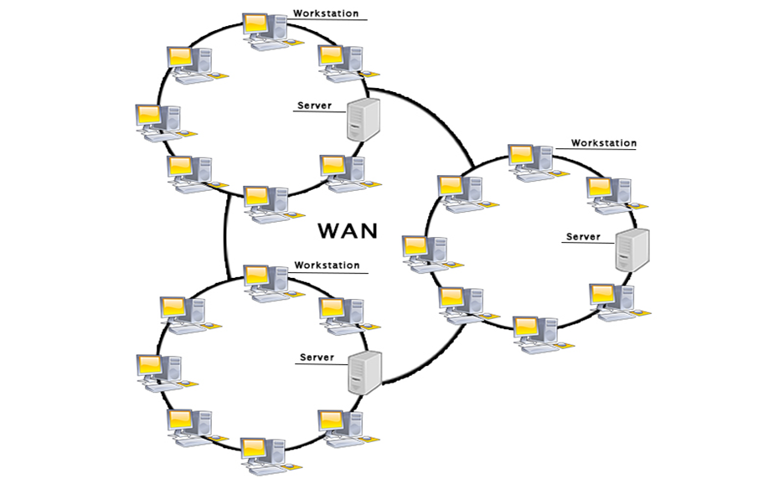

### Examples of Wide Area Network:

* **Mobile Broadband:** A 4G network is widely used across a region or country.
* **Last mile:** A telecom company is used to provide the internet services to the customers in hundreds of cities by connecting their home with fiber.
* **Private network:** A bank provides a private network that connects the 44 offices. This network is made by using the telephone leased line provided by the telecom company.

### Advantages of Wide Area Network:

Following are the advantages of the Wide Area Network:

* **Geographical area:** A Wide Area Network provides a large geographical area. Suppose if the branch of our office is in a different city then we can connect with them through WAN. The internet provides a leased line through which we can connect with another branch.
* **Centralized data:** In case of WAN network, data is centralized. Therefore, we do not need to buy the emails, files or back up servers.
* **Get updated files:** Software companies work on the live server. Therefore, the programmers get the updated files within seconds.
* **Exchange messages:** In a WAN network, messages are transmitted fast. The web application like Facebook, WhatsApp, Skype allows you to communicate with friends.
* **Sharing of software and resources:** In WAN network, we can share the software and other resources like a hard drive, RAM.
* **Global business:** We can do the business over the internet globally.
* **High bandwidth:** If we use the leased lines for our company then this gives the high bandwidth. The high bandwidth increases the data transfer rate which in turn increases the productivity of our company.

### Disadvantages of Wide Area Network:

The following are the disadvantages of the Wide Area Network:

* **Security issue:** A WAN network has more security issues as compared to LAN and MAN network as all the technologies are combined together that creates the security problem.
* **Needs Firewall & antivirus software:** The data is transferred on the internet which can be changed or hacked by the hackers, so the firewall needs to be used. Some people can inject the virus in our system so antivirus is needed to protect from such a virus.
* **High Setup cost:** An installation cost of the WAN network is high as it involves the purchasing of routers, switches.
* **Troubleshooting problems:** It covers a large area so fixing the problem is difficult.

# What is Topology?

Topology defines the structure of the network of how all the components are interconnected to each other. There are two types of topology: physical and logical topology.

Physical topology is the geometric representation of all the nodes in a network.

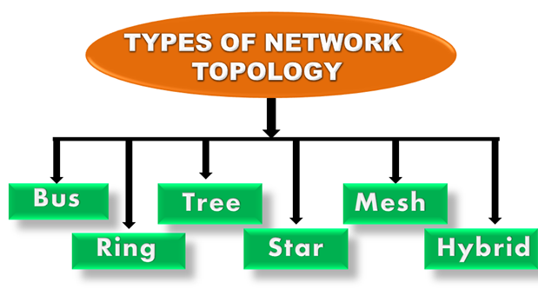

## Bus Topology

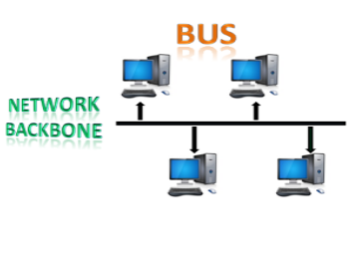

* The bus topology is designed in such a way that all the stations are connected through a single cable known as a backbone cable.
* Each node is either connected to the backbone cable by drop cable or directly connected to the backbone cable.
* When a node wants to send a message over the network, it puts a message over the network. All the stations available in the network will receive the message whether it has been addressed or not.
* The bus topology is mainly used in 802.3 (ethernet) and 802.4 standard networks.
* The configuration of a bus topology is quite simpler as compared to other topologies.
* The backbone cable is considered as a **"single lane"** through which the message is broadcast to all the stations.
* The most common access method of the bus topologies is **CSMA** (Carrier Sense Multiple Access).

**CSMA:** It is a media access control used to control the data flow so that data integrity is maintained, i.e., the packets do not get lost. There are two alternative ways of handling the problems that occur when two nodes send the messages simultaneously.

* **CSMA CD:** CSMA CD (**Collision detection**) is an access method used to detect the collision. Once the collision is detected, the sender will stop transmitting the data. Therefore, it works on "**recovery after the collision**".
* **CSMA CA:** **CSMA CA (Collision Avoidance)** is an access method used to avoid the collision by checking whether the transmission media is busy or not. If busy, then the sender waits until the media becomes idle. This technique effectively reduces the possibility of the collision. It does not work on "recovery after the collision".

### Advantages of Bus topology:

* **Low-cost cable:** In bus topology, nodes are directly connected to the cable without passing through a hub. Therefore, the initial cost of installation is low.
* **Moderate data speeds:** Coaxial or twisted pair cables are mainly used in bus-based networks that support upto 10 Mbps.
* **Familiar technology:** Bus topology is a familiar technology as the installation and troubleshooting techniques are well known, and hardware components are easily available.
* **Limited failure:** A failure in one node will not have any effect on other nodes.

### Disadvantages of Bus topology:

* **Extensive cabling:** A bus topology is quite simpler, but still it requires a lot of cabling.
* **Difficult troubleshooting:** It requires specialized test equipment to determine the cable faults. If any fault occurs in the cable, then it would disrupt the communication for all the nodes.
* **Signal interference:** If two nodes send the messages simultaneously, then the signals of both the nodes collide with each other.
* **Reconfiguration difficult:** Adding new devices to the network would slow down the network.
* **Attenuation:** Attenuation is a loss of signal leads to communication issues. Repeaters are used to regenerate the signal.

## Ring Topology

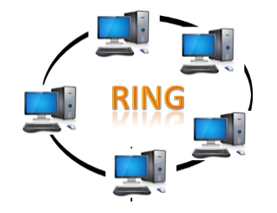

* Ring topology is like a bus topology, but with connected ends.
* The node that receives the message from the previous computer will retransmit to the next node.
* The data flows in one direction, i.e., it is unidirectional.
* The data flows in a single loop continuously known as an endless loop.
* It has no terminated ends, i.e., each node is connected to other node and having no termination point.
* The data in a ring topology flow in a clockwise direction.
* The most common access method of the ring topology is **token passing**.
  + **Token passing:** It is a network access method in which token is passed from one node to another node.
  + **Token:** It is a frame that circulates around the network.

### Working of Token passing

* A token moves around the network, and it is passed from computer to computer until it reaches the destination.
* The sender modifies the token by putting the address along with the data.
* The data is passed from one device to another device until the destination address matches. Once the token received by the destination device, then it sends the acknowledgment to the sender.
* In a ring topology, a token is used as a carrier.

### Advantages of Ring topology:

* **Network Management:** Faulty devices can be removed from the network without bringing the network down.
* **Product availability:** Many hardware and software tools for network operation and monitoring are available.
* **Cost:** Twisted pair cabling is inexpensive and easily available. Therefore, the installation cost is very low.
* **Reliable:** It is a more reliable network because the communication system is not dependent on the single host computer.

### Disadvantages of Ring topology:

* **Difficult troubleshooting:** It requires specialized test equipment to determine the cable faults. If any fault occurs in the cable, then it would disrupt the communication for all the nodes.
* **Failure:** The breakdown in one station leads to the failure of the overall network.
* **Reconfiguration difficult:** Adding new devices to the network would slow down the network.
* **Delay:** Communication delay is directly proportional to the number of nodes. Adding new devices increases the communication delay.

## Star Topology

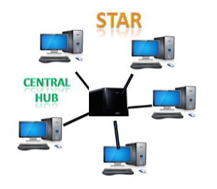

* Star topology is an arrangement of the network in which every node is connected to the central hub, switch or a central computer.
* The central computer is known as a **server**, and the peripheral devices attached to the server are known as **clients**.
* Coaxial cable or RJ-45 cables are used to connect the computers.
* Hubs or Switches are mainly used as connection devices in a **physical star topology**.
* Star topology is the most popular topology in network implementation.

### Advantages of Star topology

* **Efficient troubleshooting:** Troubleshooting is quite efficient in a star topology as compared to bus topology. In a bus topology, the manager has to inspect the kilometers of cable. In a star topology, all the stations are connected to the centralized network. Therefore, the network administrator has to go to the single station to troubleshoot the problem.
* **Network control:** Complex network control features can be easily implemented in the star topology. Any changes made in the star topology are automatically accommodated.
* **Limited failure:** As each station is connected to the central hub with its own cable, therefore failure in one cable will not affect the entire network.
* **Familiar technology:** Star topology is a familiar technology as its tools are cost-effective.
* **Easily expandable:** It is easily expandable as new stations can be added to the open ports on the hub.
* **Cost effective:** Star topology networks are cost-effective as it uses inexpensive coaxial cable.
* **High data speeds:** It supports a bandwidth of approx 100Mbps. Ethernet 100BaseT is one of the most popular Star topology networks.

### Disadvantages of Star topology

* **A Central point of failure:** If the central hub or switch goes down, then all the connected nodes will not be able to communicate with each other.
* **Cable:** Sometimes cable routing becomes difficult when a significant amount of routing is required.

## Tree topology

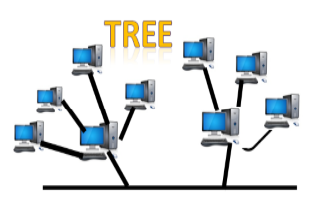

* Tree topology combines the characteristics of bus topology and star topology.
* A tree topology is a type of structure in which all the computers are connected with each other in hierarchical fashion.
* The top-most node in tree topology is known as a root node, and all other nodes are the descendants of the root node.
* There is only one path exists between two nodes for the data transmission. Thus, it forms a parent-child hierarchy.

### Advantages of Tree topology

* **Support for broadband transmission:** Tree topology is mainly used to provide broadband transmission, i.e., signals are sent over long distances without being attenuated.
* **Easily expandable:** We can add the new device to the existing network. Therefore, we can say that tree topology is easily expandable.
* **Easily manageable:** In tree topology, the whole network is divided into segments known as star networks which can be easily managed and maintained.
* **Error detection:** Error detection and error correction are very easy in a tree topology.
* **Limited failure:** The breakdown in one station does not affect the entire network.
* **Point-to-point wiring:** It has point-to-point wiring for individual segments.

### Disadvantages of Tree topology

* **Difficult troubleshooting:** If any fault occurs in the node, then it becomes difficult to troubleshoot the problem.
* **High cost:** Devices required for broadband transmission are very costly.
* **Failure:** A tree topology mainly relies on main bus cable and failure in main bus cable will damage the overall network.
* **Reconfiguration difficult:** If new devices are added, then it becomes difficult to reconfigure.

## Mesh topology

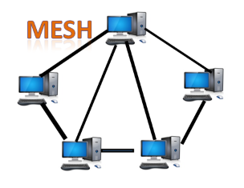

* Mesh technology is an arrangement of the network in which computers are interconnected with each other through various redundant connections.
* There are multiple paths from one computer to another computer.
* It does not contain the switch, hub or any central computer which acts as a central point of communication.
* The Internet is an example of the mesh topology.
* Mesh topology is mainly used for WAN implementations where communication failures are a critical concern.
* Mesh topology is mainly used for wireless networks.
* Mesh topology can be formed by using the formula:  
  Number of cables = (n*(n-1))/2;

Where n is the number of nodes that represents the network.

**Mesh topology is divided into two categories:**

* Fully connected mesh topology
* Partially connected mesh topology

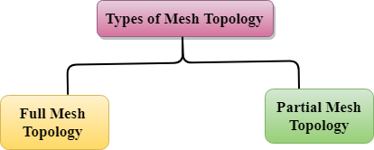

* **Full Mesh Topology:** In a full mesh topology, each computer is connected to all the computers available in the network.
* **Partial Mesh Topology:** In a partial mesh topology, not all but certain computers are connected to those computers with which they communicate frequently.

### Advantages of Mesh topology:

**Reliable:** The mesh topology networks are very reliable as if any link breakdown will not affect the communication between connected computers.

**Fast Communication:** Communication is very fast between the nodes.

**Easier Reconfiguration:** Adding new devices would not disrupt the communication between other devices.

### Disadvantages of Mesh topology

* **Cost:** A mesh topology contains a large number of connected devices such as a router and more transmission media than other topologies.
* **Management:** Mesh topology networks are very large and very difficult to maintain and manage. If the network is not monitored carefully, then the communication link failure goes undetected.
* **Efficiency:** In this topology, redundant connections are high that reduces the efficiency of the network.

## Hybrid Topology

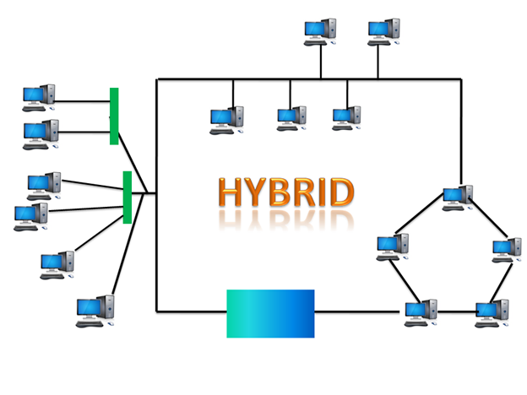

* The combination of various different topologies is known as **Hybrid topology**.
* A Hybrid topology is a connection between different links and nodes to transfer the data.
* When two or more different topologies are combined together is termed as Hybrid topology and if similar topologies are connected with each other will not result in Hybrid topology. For example, if there exist a ring topology in one branch of ICICI bank and bus topology in another branch of ICICI bank, connecting these two topologies will result in Hybrid topology.

### Advantages of Hybrid Topology

* **Reliable:** If a fault occurs in any part of the network will not affect the functioning of the rest of the network.
* **Scalable:** Size of the network can be easily expanded by adding new devices without affecting the functionality of the existing network.
* **Flexible:** This topology is very flexible as it can be designed according to the requirements of the organization.
* **Effective:** Hybrid topology is very effective as it can be designed in such a way that the strength of the network is maximized and weakness of the network is minimized.

### Disadvantages of Hybrid topology

* **Complex design:** The major drawback of the Hybrid topology is the design of the Hybrid network. It is very difficult to design the architecture of the Hybrid network.
* **Costly Hub:** The Hubs used in the Hybrid topology are very expensive as these hubs are different from usual Hubs used in other topologies.
* **Costly infrastructure:** The infrastructure cost is very high as a hybrid network requires a lot of cabling, network devices, etc.

# Transmission modes

* The way in which data is transmitted from one device to another device is known as **transmission mode**.
* The transmission mode is also known as the communication mode.
* Each communication channel has a direction associated with it, and transmission media provide the direction. Therefore, the transmission mode is also known as a directional mode.
* The transmission mode is defined in the physical layer.

The Transmission mode is divided into three categories:

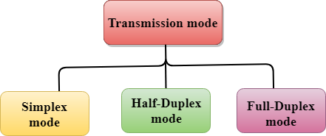

* Simplex mode
* Half-duplex mode
* Full-duplex mode

## Simplex mode



* In Simplex mode, the communication is unidirectional, i.e., the data flow in one direction.
* A device can only send the data but cannot receive it or it can receive the data but cannot send the data.
* This transmission mode is not very popular as mainly communications require the two-way exchange of data. The simplex mode is used in the business field as in sales that do not require any corresponding reply.
* The radio station is a simplex channel as it transmits the signal to the listeners but never allows them to transmit back.
* Keyboard and Monitor are the examples of the simplex mode as a keyboard can only accept the data from the user and monitor can only be used to display the data on the screen.
* The main advantage of the simplex mode is that the full capacity of the communication channel can be utilized during transmission.

### Advantage of Simplex mode:

* In simplex mode, the station can utilize the entire bandwidth of the communication channel, so that more data can be transmitted at a time.

### Disadvantage of Simplex mode:

* Communication is unidirectional, so it has no inter-communication between devices.

## Half-Duplex mode

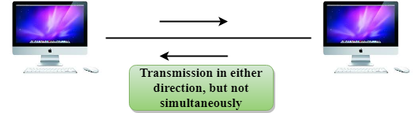

* In a Half-duplex channel, direction can be reversed, i.e., the station can transmit and receive the data as well.
* Messages flow in both the directions, but not at the same time.
* The entire bandwidth of the communication channel is utilized in one direction at a time.
* In half-duplex mode, it is possible to perform the error detection, and if any error occurs, then the receiver requests the sender to retransmit the data.
* A **Walkie-talkie** is an example of the Half-duplex mode. In Walkie-talkie, one party speaks, and another party listens. After a pause, the other speaks and first party listens. Speaking simultaneously will create the distorted sound which cannot be understood.

### Advantage of Half-duplex mode:

* In half-duplex mode, both the devices can send and receive the data and also can utilize the entire bandwidth of the communication channel during the transmission of data.

### Disadvantage of Half-Duplex mode:

* In half-duplex mode, when one device is sending the data, then another has to wait, this causes the delay in sending the data at the right time.

## Full-duplex mode



* In Full duplex mode, the communication is bi-directional, i.e., the data flow in both the directions.
* Both the stations can send and receive the message simultaneously.
* Full-duplex mode has two simplex channels. One channel has traffic moving in one direction, and another channel has traffic flowing in the opposite direction.
* The Full-duplex mode is the fastest mode of communication between devices.
* The most common example of the full-duplex mode is a telephone network. When two people are communicating with each other by a telephone line, both can talk and listen at the same time.

### Advantage of Full-duplex mode:

* Both the stations can send and receive the data at the same time.

### Disadvantage of Full-duplex mode:

* If there is no dedicated path exists between the devices, then the capacity of the communication channel is divided into two parts.

## Differences b/w Simplex, Half-duplex and Full-duplex mode

|  |  |  |  |
| --- | --- | --- | --- |
| **Basis for comparison** | **Simplex mode** | **Half-duplex mode** | **Full-duplex mode** |
| Direction of communication | In simplex mode, the communication is unidirectional. | In half-duplex mode, the communication is bidirectional, but one at a time. | In full-duplex mode, the communication is bidirectional. |
| Send/Receive | A device can only send the data but cannot receive it or it can only receive the data but cannot send it. | Both the devices can send and receive the data, but one at a time. | Both the devices can send and receive the data simultaneously. |
| Performance | The performance of half-duplex mode is better than the simplex mode. | The performance of full-duplex mode is better than the half-duplex mode. | The Full-duplex mode has better performance among simplex and half-duplex mode as it doubles the utilization of the capacity of the communication channel. |
| Example | Examples of Simplex mode are radio, keyboard, and monitor. | Example of half-duplex is Walkie-Talkies. | Example of the Full-duplex mode is a telephone network. |